WORKSHOP REPORT
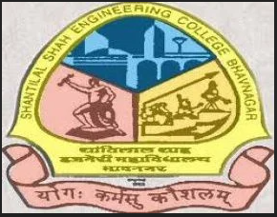 | 

An awareness seminar on Intellectual Property Rights (IPR) was conducted under SSIP 2.0 at Shantilal Shah Engineering College, Bhavnagar on 6th March 2026. The seminar was delivered by Prof. B. D. Upadhyay.
The session focused on creating awareness among students regarding the importance of Intellectual Property Rights, including patents, copyrights, trademarks, and innovation protection. Students were guided on how innovative ideas and creations can be legally protected and utilized for future development and entrepreneurship.
A total of 150 students actively participated in the event. The seminar enhanced students’ understanding of innovation security and encouraged them to value and protect their creative work.

Event Details
Particular | Details
Event Name | Awareness Seminar on IPR
Organized Under | SSIP 2.0
Venue | Shantilal Shah Engineering College, Bhavnagar
Date | 6 March 2026
Speaker | Prof. B. D. Upadhyay
Total Participation | 150 Students

Event Photographs

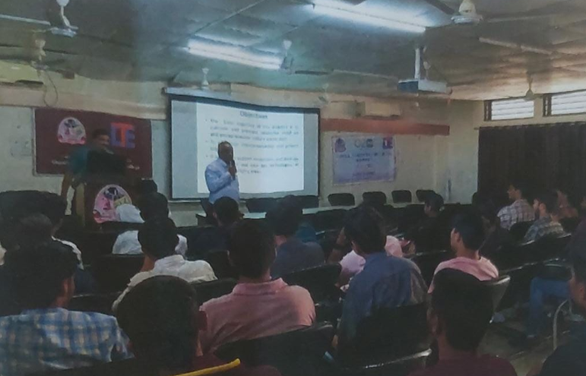
- IPR awareness seminar session under SSIP 2.0.
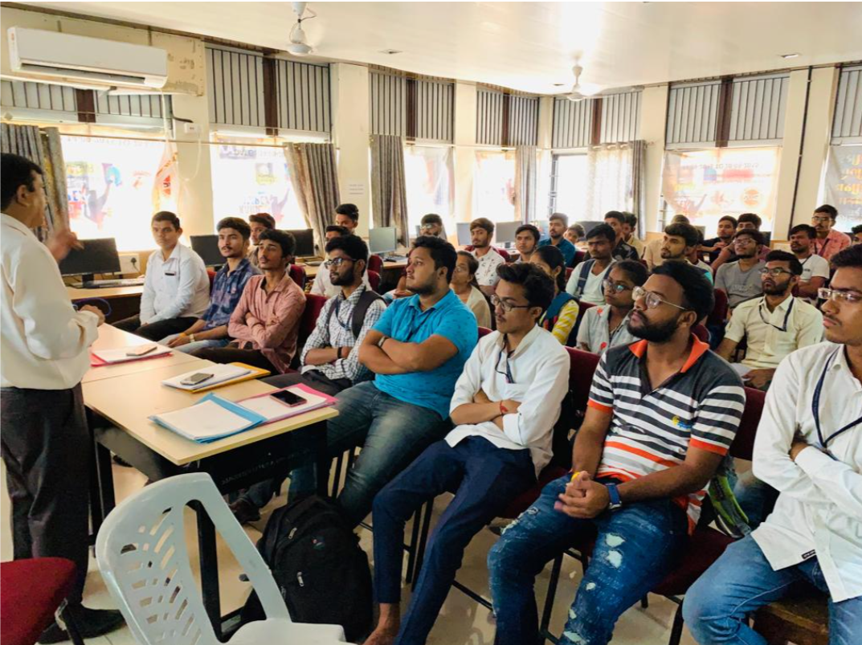
- Students attending the seminar on Intellectual Property Rights.
Conclusion
The seminar successfully created awareness about Intellectual Property Rights among students and motivated them to protect and promote their innovative ideas through proper legal frameworks.

